How to Apply:
Prospective applicants to the 2023 FerroSchool should send a ½ page motivation letter, an abstract for poster presentation and a detailed CV. The school is limited to 50 attendees. The selection of attendees will be carried out by the 2023 Ferroelectrics School committee.

Abstract: Paper Title* (use 14 pt)

1st Given Name Surname, 2nd Given Name Surname, 3rd Given Name Surname, 4th Given Name Surname (use 11 pt)
1st Name of organization (of Affiliation), email address;
2nd Name of organization (of Affiliation)
3rd Name of organization (of Affiliation)
4th Name of organization (of Affiliation)

Your abstract should provide a brief summary of the research conducted, the conclusions reached, and the potential implications of those conclusions. Highlight what is novel in your work. Avoid the use of abbreviations, footnotes, references, or mathematical equations.
You can also include one figure or one table, with references.

The abstract should be single line space with font 12pt.

Your submission should be a maximum of 500 words, in one page.

Text may be completed with a clearly readable image if needed to better describe the work. (Example image)

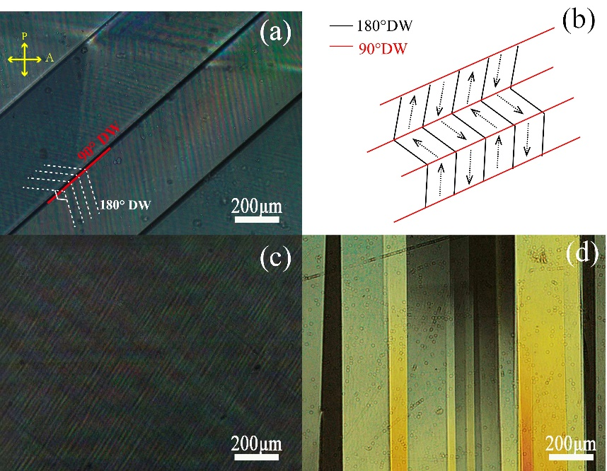
Fig. 1. (a) PLM images of the domain structure of as-grown PMN-0.38 PT. (b) Schematic of a typical embedded domain of 90° and 180° domain. PLM images of the domain structures of (c) annealed and (d) [001] pre-poled PMN-0.38 PT.

Motivation letter (use 14 pt)
Given Name Surname (use 11 pt), Given Name Surname of Your Supervisor
1st Name of organization, email address;
2nd Name of organization (of Affiliation), email address;

Your motivation letter should be a maximum of 250 words, in ½ page.

